
Western Australian Certificate of Education
Semester 2 Examination, 2022

Please place your student identification label in this box (if required)
BIOLOGY

Year 12 ATAR: Units 3 & 4

Student Number: | In figures
 | In words

Time allowed for this paper
Reading time before commencing work: ten minutes
Working time: three hours

Materials required/recommended for this paper
To be provided by the supervisor
This Question/Answer booklet
Multiple-choice answer sheet

To be provided by the candidate
Standard items: pens (black and blue preferred), pencils (including coloured), sharpener, correction fluid/tape, eraser, ruler, highlighters
Special items: non-programmable calculators approved for use in this examination

Important note to candidates
No other items may be taken into the examination room. It is your responsibility to ensure that you do not have any unauthorised material. If you have any unauthorised material with you, hand it to the supervisor before reading any further.

Structure of this Paper
Section | Number of questions available | Number of questions to be answered | Suggested working time (minutes) | Marks available | Percentage of examination
Section One  Multiple Choice | 30 | 30 | 40 | 30 | 30
Section Two  Short answer | 5 | 5 | 90 | 100 | 50
Section Three  Extended answer | 4 | 2 | 50 | 40 | 20
 |  |  |  | Total | 100

Instructions to candidates

- The rules for the conduct of the Western Australian external examinations are detailed in the Year 12 Information Handbook 2022: Part II. Sitting this examination implies that you agree to abide by these rules.
- Write your answers in this Question/Answer booklet preferably using a blue/black pen. Do not use erasable or gel pens.
- Answer the questions according to the following instructions. Section One should be answered on the Multiple-Choice answer sheet. Sections Two and Three: Write your answers in this Question/Answer booklet. Wherever possible, confine your answer to the line spaces provided.
Section Three: Consists of four questions. You must answer two of the four questions.
- You must be careful to confine your answers to the specific questions asked and to follow any instructions that are specific to a particular question.
- Supplementary pages for planning/continuing your answers to questions are provided at the end of this Question/Answer booklet. If you use these pages to continue an answer, indicate at the original answer where the answer is continued, i.e. give the page number.

Section One: Multiple-choice 30% (30 marks)
This section has thirty questions. Answer all questions on the separate Multiple-choice answer sheet provided. For each question shade the box to indicate your answer. Use only a blue or black pen to shade the boxes. Do not use erasable or gel pens. If you make a mistake, place a cross through that square, then shade your new answer. Do not erase or use correction fluid/tape. Marks will not be deducted for incorrect answers. No marks will be given if more than one answer is completed for any question.
Suggested working time: 40 minutes.

- Which of the following statements is the best example of an observation?
- Kangaroos gather at a waterhole at the same time each day.
- The bilby burrowed to get away from the heat.
- Female spiders eat their mates to reduce competition for food.
- The dolphins at Monkey Mia must like people because they come close to the shoreline.

- Which of the following lists the correct sequence of steps in a scientific investigation?
- hypothesis, prediction, question, observation, experiment, conclusion
- question, hypothesis, prediction, experiment, observation, conclusion
- observation, question, prediction, hypothesis, experiment, conclusion
- question, observation, hypothesis, prediction, experiment, conclusion

- Tortoises are terrestrial reptiles that are almost all herbivorous. Some tortoises can produce both urea and uric acid as nitrogenous waste products. What is the best explanation for this adaptation?
- The tortoises’ diet is so high in protein that they need to produce both types of waste to excrete it all.
- The tortoises excrete urea when food is plentiful and they have extra energy reserves to produce it, and then excrete uric acid when food is scarce.
- The tortoises’ kidneys are malfunctioning and should only produce one type of waste.
- The tortoises excrete uric acid in periods of low rainfall and urea during wet periods.

- Which of the following is NOT true of viruses?
- They are highly host specific and always pathogenic.
- They replicate as they circulate in the bloodstream.
- A virus is not considered to be living because it cannot function outside a host cell.
- They consist of a core containing nucleic acid, plus a protein coat.

- Which of the following correctly lists characteristics of fungal cells?
- They are autotrophic and all are pathogens
- They have a cell wall made of cellulose and carbohydrate.
- They contain RNA and circular plasmids.
- They mainly reproduce asexually by spores but can also reproduce sexually via the fusion of haploid cells

- Passive defences in plants include all of the following EXCEPT
- thorns or spines on the leaves
- a thick, waxy cuticle
- the presence in leaves of compounds that disrupt the life cycle of insect predators
- an increase in the production of hydrogen peroxide which kills invading cells

- Which of the following can cause mutations?
- Errors in DNA replication
- Errors in cell division
- Damage to DNA by physical or chemical factors in the environment
- All of the above.

- Each of the following diseases is caused by a bacterium EXCEPT
- tuberculosis
- malaria
- tetanus
- crown gall of plants

- Fish excrete which form of nitrogenous waste?
- ammonia
- amino acids
- urea
- uric acid
- If a cross between a yellow flowered plant and a white flowered plant produced 54 yellow flowers and 51 white flowers, and yellow is dominant, then the most likely genotypes involved are
- two plants heterozygous for yellow and white flowers.
- a homozygous yellow flower and a homozygous white flower.
- a heterozygous yellow flower and a homozygous white flower.
- a heterozygous yellow flower and a heterozygous white flower.

- If two heterozygous yellow flowers are crossed, the likely ratio of yellow to white flowers is
- 3 yellow: 1 white
- 3 white: 1 yellow
- 1 white: 1 yellow
- All yellow

- A disease is considered to be endemic if
- It causes serious loss of life in a population
- It is always present in a particular location or population
- It has spread across international borders
- It is spread by native plants or animals

- The deformed wing condition in honey bees is caused by a virus. It can be spread by either a bite from a varroa mite or transmission from bee to offspring. These modes of transmission are respectively called
- Direct and indirect
- Indirect and direct
- Both indirect
- Both direct

- Crown gall in plants is caused by
- A fungus
- A virus
- A bacterium
- An insect infestation

Table 1 below refers to human blood groups.
Use this diagram to answer Questions 15 & 16.

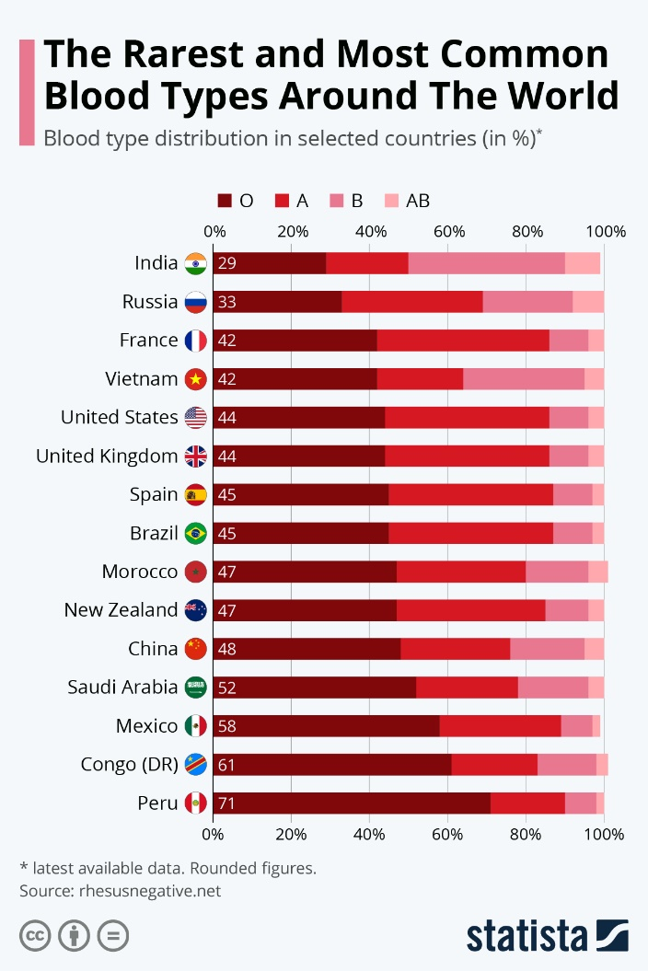

Table 1: The distribution of human blood groups

- Which country has the largest proportion of blood group AB?
- China.
- Russia.
- Morocco.
- India.

- The mode of inheritance in blood groups is
- Sex linked.
- Incomplete dominance.
- Co-dominance.
- Autosomal dominance.

- Ross River Virus can spread by
- An infected person making contact with a handrail in a railway station
- Exchange of body fluids via sexual contact
- Droplets formed by an infected person’s sneeze
- A bite from an infected mosquito vector

- The function of the enzyme ligase is to
- separate the strands of DNA during replication.
- collect free nucleotides and bring them to the DNA strand during replication.
- join fragments of DNA together during replication.
- break down the nuclear membrane prior to cell division.

Use the information below to answer Questions 19 to 21.

A biologist collected leaves from a plant that had moth eggs laid on them. He collected 4 leaves with a total of 100 eggs on them. He then divided the leaves (without harming the eggs) into 2 groups of 50 eggs, and placed them into containers that were the same size and shape. One group was placed in a dark container, the other in a container exposed to light. Both containers were kept at 20°C, and the leaves were sprayed with water to maintain their moisture levels. The number of eggs that hatched each day was recorded over a two week period.

Below is a list of the variables in this experiment:

1. the number of eggs in each container
2. the temperature
3. the light conditions
4. the number of eggs that hatched each day
5. the spraying of water onto the leaves
6. the size and shape of the containers
- The independent variable for this experiment is
- 1.
- 2.
- 3.
- 4.
- The dependent variable for this experiment is
- 1
- 2.
- 3.
- 4.

- The controlled variables for this experiment are
- 1, 2, 5, and 6
- 1, 2, 4, and 5
- 1, 2, 3, and 6
- 1, 2, 4, 5, and 6

- Mitosis and meiosis are both forms of cell division. The major difference between them is
- Mitosis produces gametes, meiosis produces body cells.
- Meiosis only occurs in animals but mitosis occurs in plants and animals.
- Mitosis is used for growth and repair, meiosis is used for reproduction.
- Mitosis results in 4 daughter cells, meiosis results in 2 daughter cells.

- As the Covid-19 pandemic has progressed, the use of PCR testing has become commonplace. What does PCR achieve?
- It separates strands of DNA according to size.
- It makes a very large number of copies of small samples of DNA.
- It analyses the DNA and so identifies individuals.
- It stops the spread of diseases like Covid-19.

- Genetic profiling has several benefits as a strategy in the conservation of endangered species. Which of the following is NOT an example of the use of genetic profiling?
- Comparing samples of whale meat to ensure that they are not taken from protected species.
- Establishing the relatedness of captive breeding animals in zoos and nature reserves.
- Setting aside reserves for the release and re-introduction of captive bred animals into their former habitat.
- Taking samples from the environment to track the distribution of endangered species.

- DNA molecules have a particular structure that includes the pairing of nucleotides. The rule for the pairing of bases is
- Adenine with guanine, and cytosine with thymine
- Adenine with thymine, and cytosine with guanine
- Adenine with cytosine, and thymine with guanine
- Adenosine with thiamine, and cytosine with guanine

- The two ends of the strands of the double helix of DNA are usually labelled 5’ and 3’. This is due to
- The location of the chemical bonds that join the phosphate groups to the deoxyribose sugar
- A need to distinguish between the two ends of the molecule.
- The number of phosphate groups attached to the deoxyribose sugar.
- The way that the nucleotides form hydrogen bonds between each other.

Questions 27 – 28 refer to the diagram below showing gene cloning. The cloning vector is a bacterial plasmid.

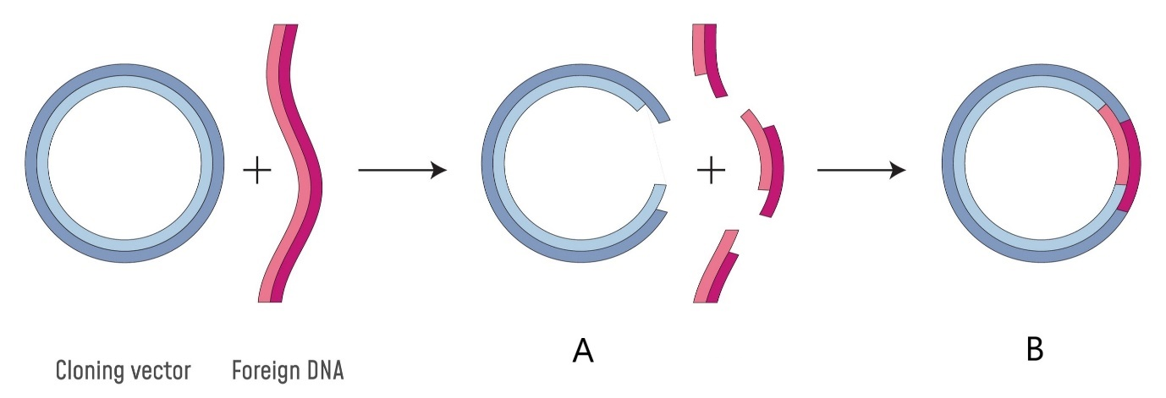

- How are the breaks in the vector and the foreign DNA made giving the image shown in A?
- By using PCR to produce fragments of DNA.
- By using restriction enzymes that cut the DNA at a particular sequence of bases.
- By physical manipulation using micro-probes under the microscope
- By heating the samples so that the DNA separates into single strands which are easy to split.
- What happens to the structure labelled B once it is completely joined, as in the diagram?
- It is inserted into a host organism by a gene gun.
- It is added to a bacterial culture where it is taken up by some bacteria.
- The inserted gene is expressed by the host cells.
- All of the above are possibilities.

- Which of the following methods of thermoregulation in animals is NOT a structural feature?
- Thick fur on polar bears
- High concentrations of blood vessels close to the surface of the skin
- Kangaroos lick their wrists on hot days.
- Thick layers of blubber in marine mammals.

- Water balance is vital to living organisms. Plants growing in hypersaline soils will be at a disadvantage because
- The salt competes with other soil nutrients, which cannot be taken up
- Water will move via osmosis from the plant to the soil
- Water will move via osmosis from the soil to the plant
- Plants have no use for salt because they don’t sweat.

END OF SECTION ONE

LEFT BLANK INTENTIONALLY

Section Two: Short answer 50% (100 Marks)
This section has 5 questions. Answer all questions. Write your answers in the spaces provided.
Supplementary pages for planning/continuing your answers to questions are provided at the end of this Question/Answer booklet. If you use these pages to continue an answer, indicate at the original answer where the answer is continued, i.e., give the page number.
Suggested working time: 90 minutes.

- (20 marks)
A group of biology students was carrying out an experiment on the rate of transpiration in three different plants. The apparatus they used (a potometer) is shown below. As the plant transpires, the air bubble moves along the tubing, and the volume of water lost to the air can be measured.

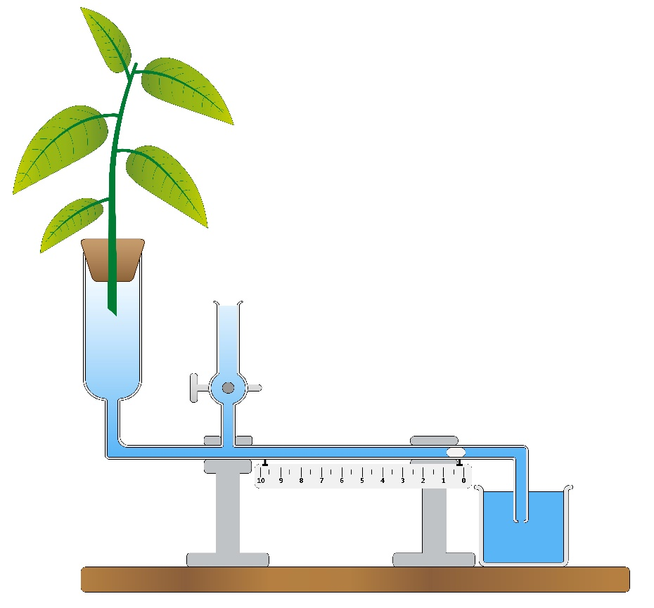
Air bubble
Leafy shoot

The three species of plant used in the experiment were a eucalypt from the desert, a rose bush from the school garden, and spinifex grass from a sand dune. The pieces of plant cut for the experiment all had the same mass, and were kept at the same temperature throughout the experiment. There were 5 groups of students, and each group had 2 samples of leaves from each type of plant. The results from the experiment are shown on the next page.

Plant type | Volume of water transpired (mL) in 15 minutes
 | eucalypt | rose | spinifex
Group 1 | 3.8 | 4.9 | 1.1
 | 3.6 | 5.1 | 1.0
Group 2 | 3.7 | 5.0 | 1.2
 | 3.6 | 4.8 | 1.0
Group 3 | 3.3 | 4.9 | 1.3
 | 3.2 | 4.7 | 0.9
Group 4 | 3.5 | 4.3 | 0.9
 | 3.6 | 4.2 | 1.1
Group 5 | 3.7 | 4.4 | 1.2
 | 3.8 | 4.2 | 0.8
Mean

- Calculate the missing mean values for each column and write your answers in the space in the table. (3 marks)

- Write a possible hypothesis for this experiment (2 marks)

- Name three (3) controlled variables in this experiment. (3 marks)
One:
Two:
Three:
- Name the dependent and the independent variables in this experiment.
(2 marks)
Dependent variable:
independent variable:
- Graph the mean values on the grid below (5 marks)
There is a spare grid on page 50. If you need to redraw your graph on the spare grid, clearly show that graph below is cancelled.

- The plant that lost the least water was the spinifex. Name 2 structural adaptations that this plant may have to help it to reduce water loss. (2 marks)
Adaptation 1:

Adaptation 2:

- If the students set up a fan and blew air over the leafy shoot, what would you predict would happen to the volume of water lost? Explain your answer briefly.
(3 marks)

- (20 marks)
Thermoregulation is the control of the body’s temperature. It is common in endothermic animals, which can alter their metabolic rate to create more heat when the environmental temperature falls. Metabolic control of temperature also occurs in some plant species, such as members of the aroid family. The photograph below shows a skunk cabbage (Symplocarpus foetidis) growing in snow, which has melted around the plant as it produces heat.
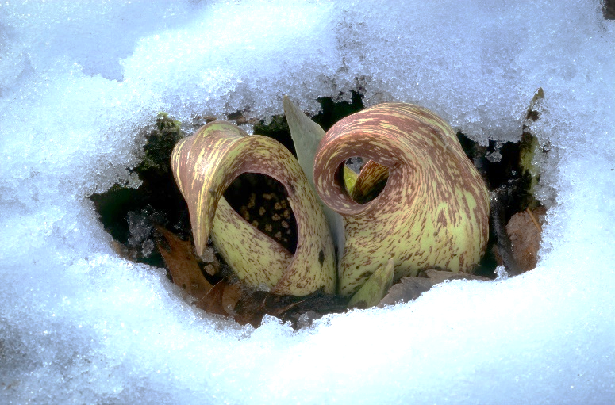
Spathe

Spadix

The heat-producing organ is called the spadix, a spike of tiny flowers closely arranged around a fleshy axis. It is contained within the spathe, which wraps around the flower. Heat is produced by a form of cellular respiration, and is initiated by plant hormones. These plants are pollinated by beetles, which are attracted by scent produced within the spathe.
- List three (3) advantages that producing heat gives to this plant. (3 marks)
One:

Two:

Three:

- Other than the metabolic method described above, describe two (2) structural and one (1) physiological adaptation that enable plants to cope with high temperatures.
(6 marks)

- Some mammals, including humans and horses, use sweat as a means of heat loss. Explain why sweating reduces the heat load of an organism. (2 marks)

- Briefly explain the effect of body size on the heat budget (i.e., how much heat is gained/lost) of organisms. (5 marks)

- Ectothermic animals such as reptiles have a range of behavioural adaptations to aid in temperature regulation. Name two (2) examples of behavioural adaptations used by reptiles and state how they help to control the body temperature of the animal.
(4 marks)
One:

Two:

- (20 marks)
- Many pathogenic bacteria have evolved a resistance to the antibiotics that have been used in the past to treat infections. These resistant forms cause significant problems for people or animals that become infected with them. Describe how such resistance develops in bacterial groups. (5 marks)

- Explain the process of allopatric speciation. (5 marks)

- The organisms below are all marine and represent 3 different Classes of vertebrates. Despite not having a common ancestor for approximately 450 million years, these organisms have very similar body shapes and diets. What factors have led to these animals looking so similar? (A is a shark, B is an extinct ichthyosaur, C is a dolphin and D is a killer whale). (5 marks)

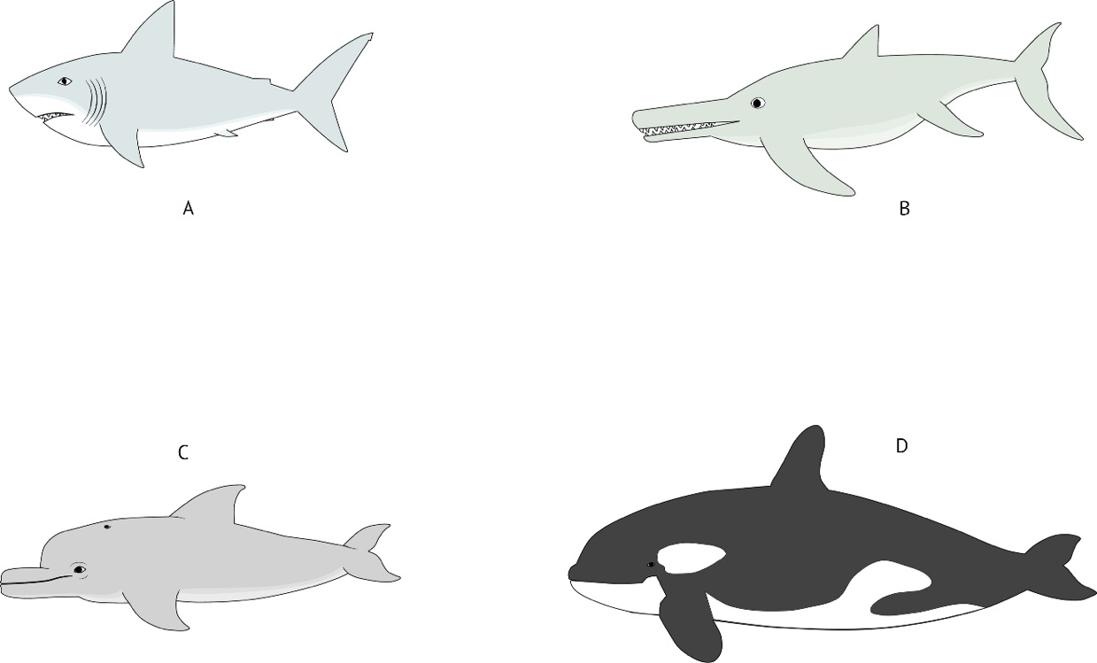

- What is the difference between natural selection and sexual selection, and how does the latter impact on the allele frequencies in a population? (3 marks)

- What is meant by the term “genetic drift”? (2 marks)

- (20 marks)
- Explain briefly how each of the following factors impacts on the spread of a contagious disease that infects humans. (4 marks)
- Socio-economic status:

- Global travel:

- Population density:

- Mode of transmission:

- Explain how each of the following is used to control the spread of diseases. (8 marks)
- Immunisation:

- Quarantine:

- Medications:

- Physical prevention:

- Describe the structure and mode of transmission of the following pathogenic organisms: (8 marks)
- Crown gall of plants:

- Chytridiomycosis:

- Phytophthora dieback:

- Malaria:

- (20 marks)
- Define the term “osmoregulation” and name the process by which water moves in and out of cells. (3 marks)

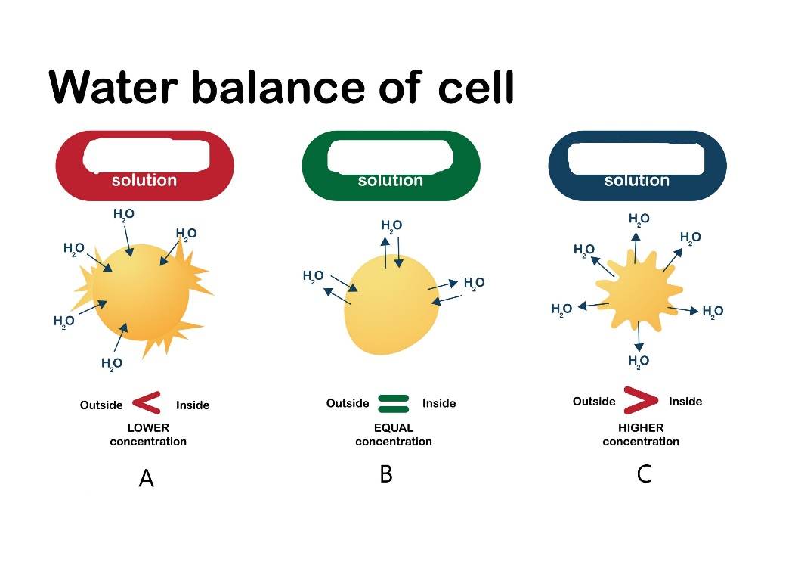
- The diagram below shows the movement of water into and out of a cell. The solutions around the cells are either less concentrated, more concentrated or the same concentration as the inside of the cell, but the labels have been erased. Write the correct scientific term for each of the solutions shown by the letters A – C. (3 marks)

A:
B:
C:

- The fish below is a carp, which lives in a fresh water habitat. Briefly describe how each of the labelled parts contributes to the maintenance of water balance in this fish.
(4 marks)

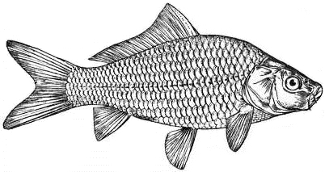
Gills
Kidneys
Scales
Mouth

Scales
Kidneys
Gills
Mouth

- Using a named example of an Australian animal, briefly describe how a species that lives in the desert can survive with minimal availability of water. (5 marks)

- Using a named example of an Australian plant, describe the adaptations that allow it to grow successfully in a saline environment. (5 marks)

END OF SECTION TWO

Section Three: Extended Answer 20% (40 Marks)
This section contains 4 questions. Questions 36 and 37 are from Unit 3. Questions 38 and 39 are from Unit 4. Answer 1 question from Unit 3 and 1 question from Unit 4.
Use a blue or black pen, and a pencil for diagrams and graphs. Responses can include: labelled diagrams with explanatory notes; lists of points with linking sentences; labelled tables and/or graphs; annotated flow diagrams with introductory notes.
Supplementary pages for planning/continuing your answers to a question are provided at the end of this Question/Answer booklet. If you use these pages to continue an answer, indicate at the original answer where the answer is continued, i.e. give the page number.
Suggested working time: 50 minutes.

Choose either Question 36 or Question 37.

Indicate which question you are answering by ticking the box. Write your answer to question 36 or 37 on the pages following Question 37, and your answer to Question 38 or 39 from page 30.

Question 36 (20 marks)
- Discuss four different patterns of inheritance and how they influence the relative proportions of offspring to produce different phenotypes and genotypes. (10 marks)

- Describe how the genetic code holds the information needed to allow the organism to function, and how that information is used to produce proteins. (10 marks)

Question 37 (20 marks)
- Mutation refers to a permanent, heritable change in the DNA of an organism. Describe how mutations can arise, and discuss the impact that they have on the organism.
(10 marks)

- Phylogenetic trees can be used to represent evolutionary relationships. Outline the steps involved in creating these trees, and discuss the reasons that they are subject to change over time. (10 marks)

Questions 38 and 39 are on page 41

Question number:

Question number:

Question number:

Question number:

Question number:

Question number:

Question number:

Question number:

Choose either Question 38 or Question 39.

Indicate which question you are answering by ticking the box.

Question 38 (20 marks)
- Explain how feedback mechanisms operate within organisms to maintain homeostasis.
(10 marks)

- Using named examples, discuss the impact of climate change on the spread of diseases. (10 marks)

Question 39 (20 marks)
- Discuss the energy costs involved in the production of different types of nitrogenous wastes, and the advantages and disadvantages of each type in different environments.
(10 marks)
- Viral diseases include influenza, Ross River virus and the bat lyssavirus. Describe the structure of viruses in general, then chose one of these and discuss the mode of transmission, impact on the affected individual and what treatments are available.
(10 marks)

Question number:

Question number:

Question number:

Question number:

Question number:

Question number:

Question number:

Question number:

Spare grid.

Supplementary page
Question number:

Supplementary page
Question number:

Supplementary page
Question number:

Supplementary page
Question number:

Supplementary page
Question number:

Supplementary page
Question number:

ACKNOWLEDGEMENTS

Question 15: | The Blood Type Distribution Around the World downloaded under private account  Image: https://www.statista.com/chart/25386/blood-type-distribution-selected-countries/  Author: Claire Jenik 22/07/2021
Questions 27: | “Gene cloning. Plasmid and recombinant DNA” by Honourr used under permission form Shutterstock  Image: https://www.shutterstock.com/image-vector/gene-cloning-plasmids-recombinant-dna-2148808119  Author: www.shutterstock.com/Honourr
Question 31: | “Potometer with leafy shoot, ruler and stand” by Biology Education used under permission from Shutterstock  Image: https://www.shutterstock.com/image-illustration/potometer-leafy-shoot-ruler-stand-1958120458  Author: www.shutterstock.com/ Biology education
Question 32 (a): | “Skunk cabbage blooming after a snow storm” by Gerry Bishop used under permission from Shutterstock  Image: https:// https://www.shutterstock.com/image-photo/flowers-skunk-cabbage-symplocarpus-foetidus-blooming-1352232041  Author: www.shutterstock.com/Gerry Bishop
Question 33 (c) | “Convergent evolution of shark, ichthyosaur, dolphin and killer whale” by Sergey Mukilov used under permission from Shutterstock  Image: https:// https://www.shutterstock.com/image-vector/convergent-evolution-shark-ichthyosaurus-dolphin-killer-1574905360  Author: www.shutterstock.com/Sergey Mukilov
Question 35 (a): | “Water balance of cell” by Big Bear Camera used under permission from Shutterstock  Image: https://www.shutterstock.com/image-vector/biology-diagram-show-effect-isotonic-hypertonic-1756773080  Author: www.shutterstock.com/Big Bear Camera
Question 35 (c): | “The common Carp”  File EB1911  Used under permission from Creative Commons CC0 license

